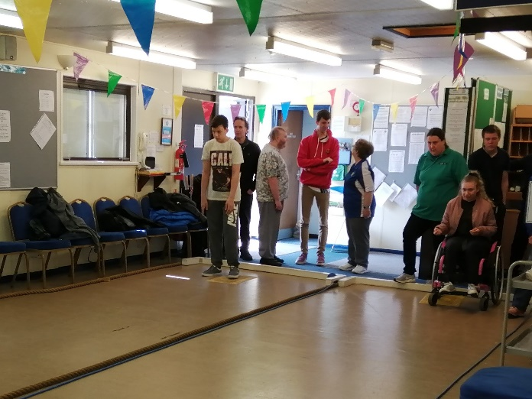
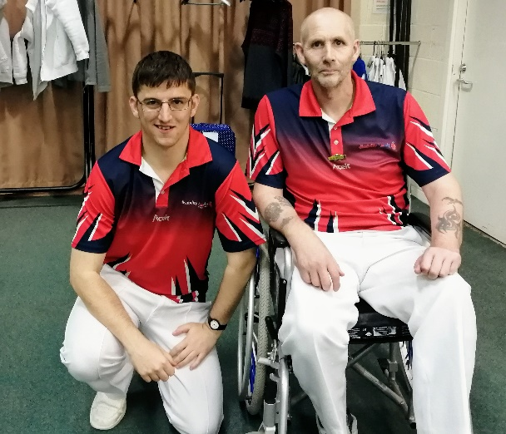
The Winners of the 2019 Love Fisher Brown Award are Announced!

The 2019 Love Fisher Brown Award, sponsored by Para Handy and Drakes Pride, was created to recognise clubs that provide disabled participation opportunities for their bowlers. This award, named after the remarkable and inspiring Commonwealth Games achievements of Bob Love, David Fisher and Paul Brown, showcases the excellent work being undertaken by clubs with disabled bowlers around the country, and provide a benchmark for other clubs to aspire to. The Disability Steering Group panel, comprised of representatives from the Activity Alliance, Bowls Development Alliance, Bowls England, Disability Bowls England and English Indoor Bowling Association, assessed each of the 12 strong nominations, and after much discussion and thought are delighted to announced that the following entries have been selected as this year’s prize winners:
- 2019 Love Fisher Brown Award Winners – The Griffin Bowls Club
- 2019 Love Fisher Brown Award Runner Up – Kempston Park Indoor Bowls Club
- 2019 Love Fisher Brown Award Runner Up – Lincoln & District Indoor Bowls Club
Furthermore, for their outstanding achievements over the past year and the quality of their nominations, the following clubs have been Highly Commended: Charnwood IBC, Oundle BC, Desborough IBC.

Ann King, the Griffin Bowls Club’s secretary reacted to the news on behalf of the club: “We are very excited to have won this award. So many people have worked very hard this year to achieve so much in such a short time!”
On behalf of the award panel, George Babalev (Club Development Co-ordinator and Disability Lead for the Bowls Development Alliance) said: “For a second year in a row the standard of the nominations was exceptionally high and the nature of the activities detailed within them were both inspiring and humbling. I congratulate all of this year’s nominated clubs for their commendable efforts towards making the sport and their clubs more inclusive. I hope they all continue to build on the successes of 2019 and progress even further next year in their endeavour to provide opportunities for disabled people to participate in bowls.”

Over the next few months, we will release more information about the Griffin Bowls Club, the two runners-up and some of the other nominated clubs, to showcase their fantastic achievements.

For more details on the Love Fisher Brown Award, contact disability@playbowls.org.

