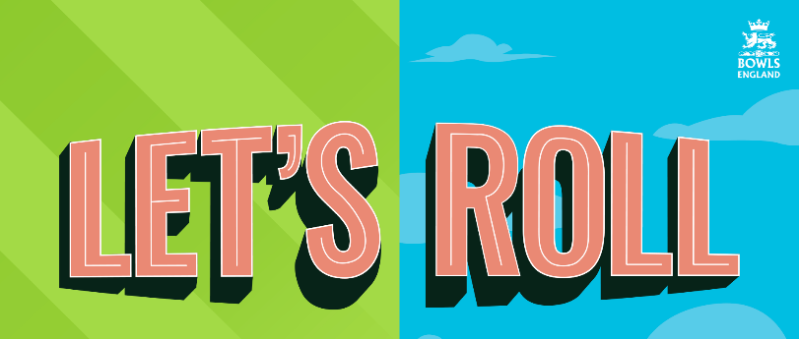
2020 Let’s Roll! Attendance Monitoring Form

Club
County
Club Co-ordinator

We want to continue to support clubs to recruit new bowlers through national initiatives. We request that you complete this form in as much detail as possible in order that we can
measure the success of ‘Let’s Roll’ and provide relevant support and resources to our clubs in the future.

PARTICIPANT NAME |  | GENDER | EMAIL ADDRESS | POST CODE | HEALTH, AGE & ETHNICITY  (Please fill in the relevant codes from the boxes below) |  |  | JOINED |  | DATA PROTECTION | PARTICIPANT  SIGNATURE | HOW DID YOU FIND OUT ABOUT THE EVENTS?
FORENAME | SURNAME | M/F/O*  *Other | Please enter your email address if you would like to receive Bowls England’s  e-newsletter | Please can you provide your home post code | Health  See box 1 below | Age  See box 2 below | Ethnicity  See box 3 below | YES | NO | Please tick to confirm you  agree with  Bowls England’s  Privacy Policy | Please sign below to confirm that you have attended a free introductory session to lawn bowls
John | Smith | M | email@example.com | LE13 0PB | A4 | 3 | A1 |  |  |  | John Smith | Facebook Advert

BOX 2: AGE RANGE
Please enter once of the following codes into the Age Range box above that corresponds with your age range:

A1: Under 18 A2: 18 – 39 A3: 40 – 54 A4: 55 – 64 A5: 65 – 74 A6: 75+

A7: Prefer not to say
BOX 1: HEALTH - Are any of the health issues below relevant to you?
To help you complete the health box above, please use the codes below:

0: No long-standing illness or disability
1: Vision (due to blindness or partial sight)
2: Mobility (difficulty walking short distances, climbing stairs, lifting & carrying objects)
3: Hearing (due to deafness or partial hearing)
4: Learning or concentrating or remembering
5: Mental Health
6: Stamina or breathing difficulty
7: Social or behavioural issues (due to neuro diverse conditions such as Autism,
Attention Deficit or Asperger’s’ Syndrome)
8: Difficulty speaking or making yourself understood
9: Dexterity difficulties (lifting, grasping or holding objects)
10: Long-term pain or discomfort (that is always present or reoccurs from time to time)
11: Other long-standing illness and/or disability 12: Prefer not to say

BOX 3: ETHNICITY
Please enter one of the following codes into the ethnicity box above that correspondences with your ethnicity:

A: White B: Mixed C: Asian or Asian Black D: Black or Black British E: Chinese or Other Ethnic Groups
A1 - British B1 - White & Black Caribbean C1 – Indian D1 – Caribbean E1 - Chinese
A2 - Irish B2 - White & Black African C2 – Pakistani D2 – African E2 - Other
A3 - Other B3 - White & Asian C3 – Bangladeshi D3 - Other
B4 – Other C4 – Other F1 – Prefer not to say

Please return completed forms to jamie@bowlsengland.com by 30th September to be entered into a free prize draw supported by Drakes Pride.
Three clubs, drawn at random, will receive two sets of Drakes Pride bowls that can be used in support of their future recruitment initiatives.

