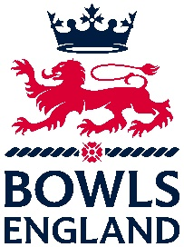
Associate Membership Application Form
To apply for Associate Membership, please complete all the sections below and return the form to the Bowls England Headquarters.
Details

Name of Association or League:

Contact Name:

Contact Address:

Contact Email:

Contact Phone:

Please complete a brief history (including formation) about your League or Association

Geographical spread of matches/venue/opposition

General aims and objectives of your League or Association

Details of Competitions through the year

Any charity donations or fundraising activities

Any other supporting information about your League or Association

Declaration

I, ......................................................................... confirm that all the members of (name of association).............................................................. are affiliated to Bowls England through their respective clubs.

Signed: ..........................................................................................................
Date: ............................................................................................................

Please return this form to:
The Chief Executive, Bowls England, Riverside House, Milverton Hill, Royal Leamington Spa, CV32 5HZ

