How to edit the Safeguarding PDF Poster

Open the PDF, and go to the edit tab below:

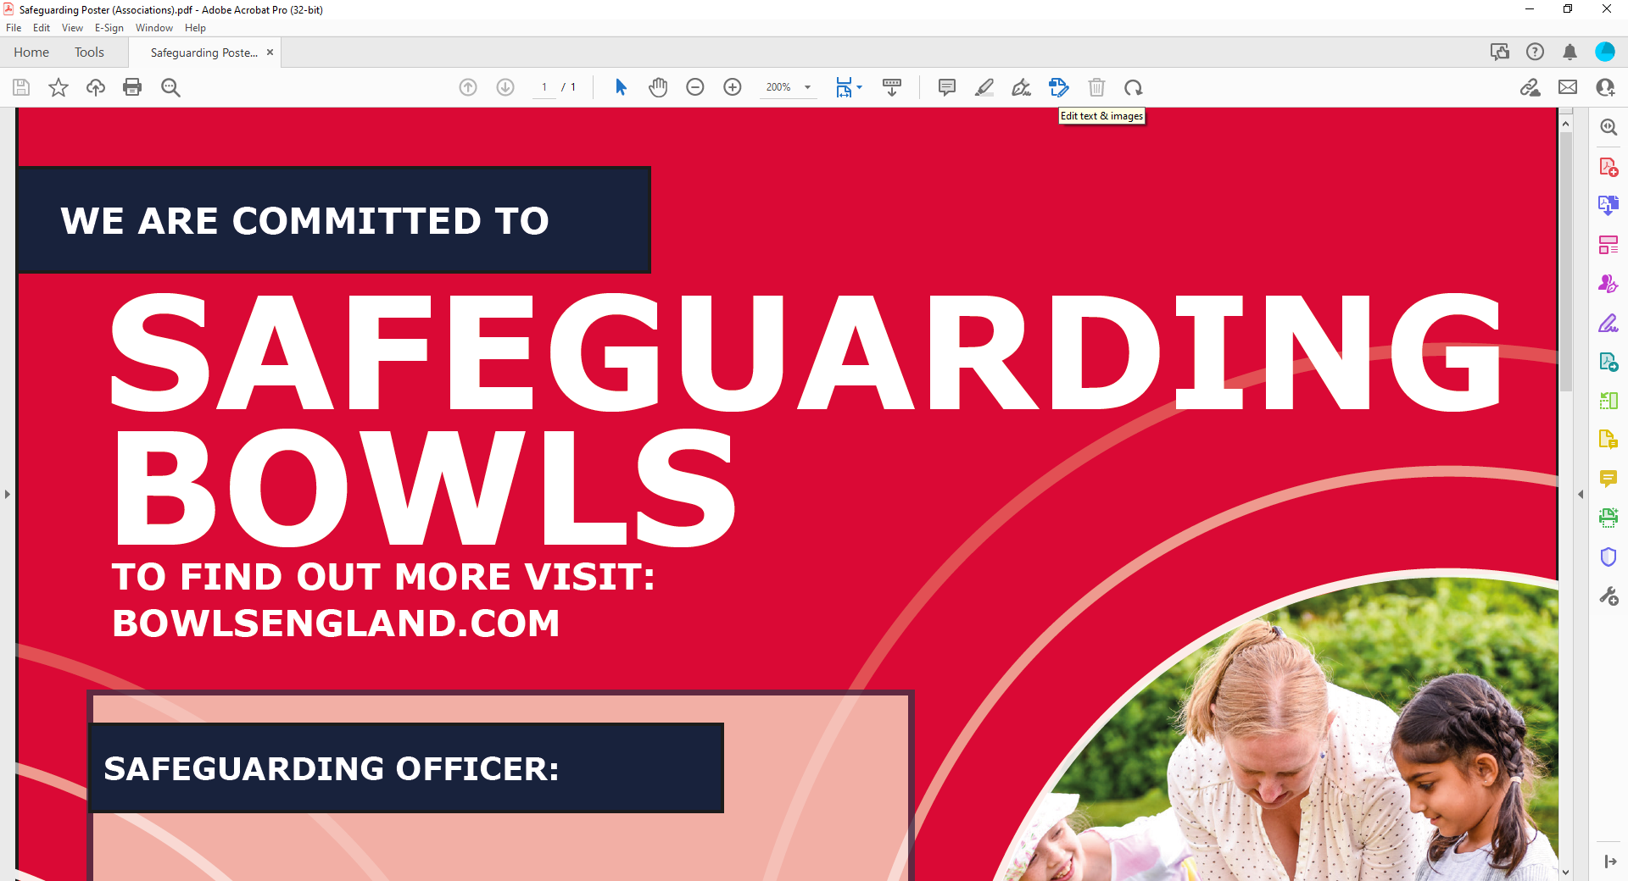

Then click ‘Add Text’:

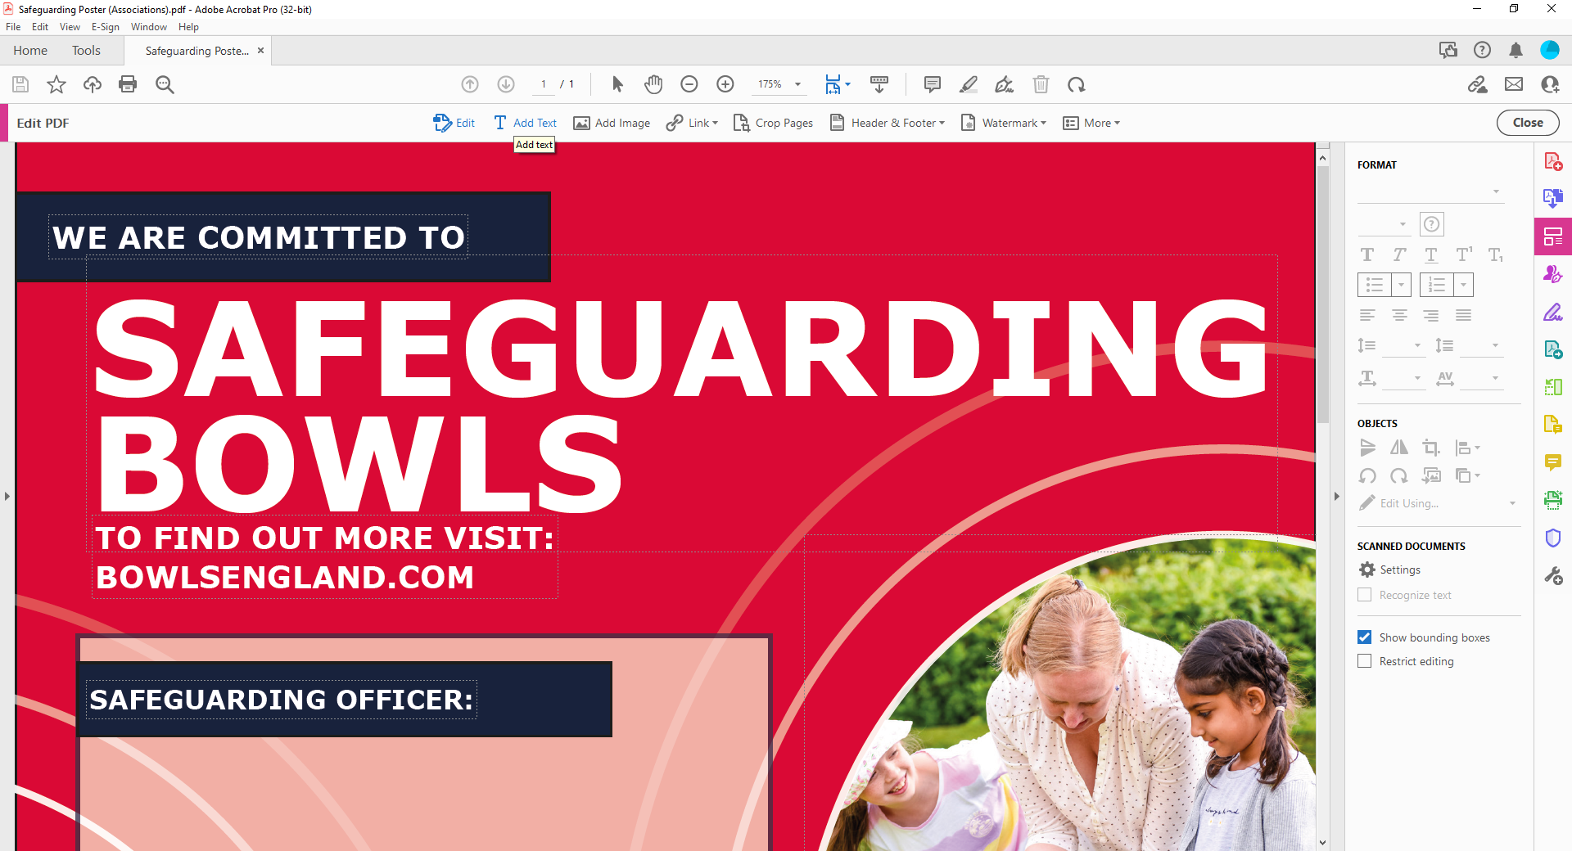

This will then enable you to add text anywhere in the document, click where you want and start typing:

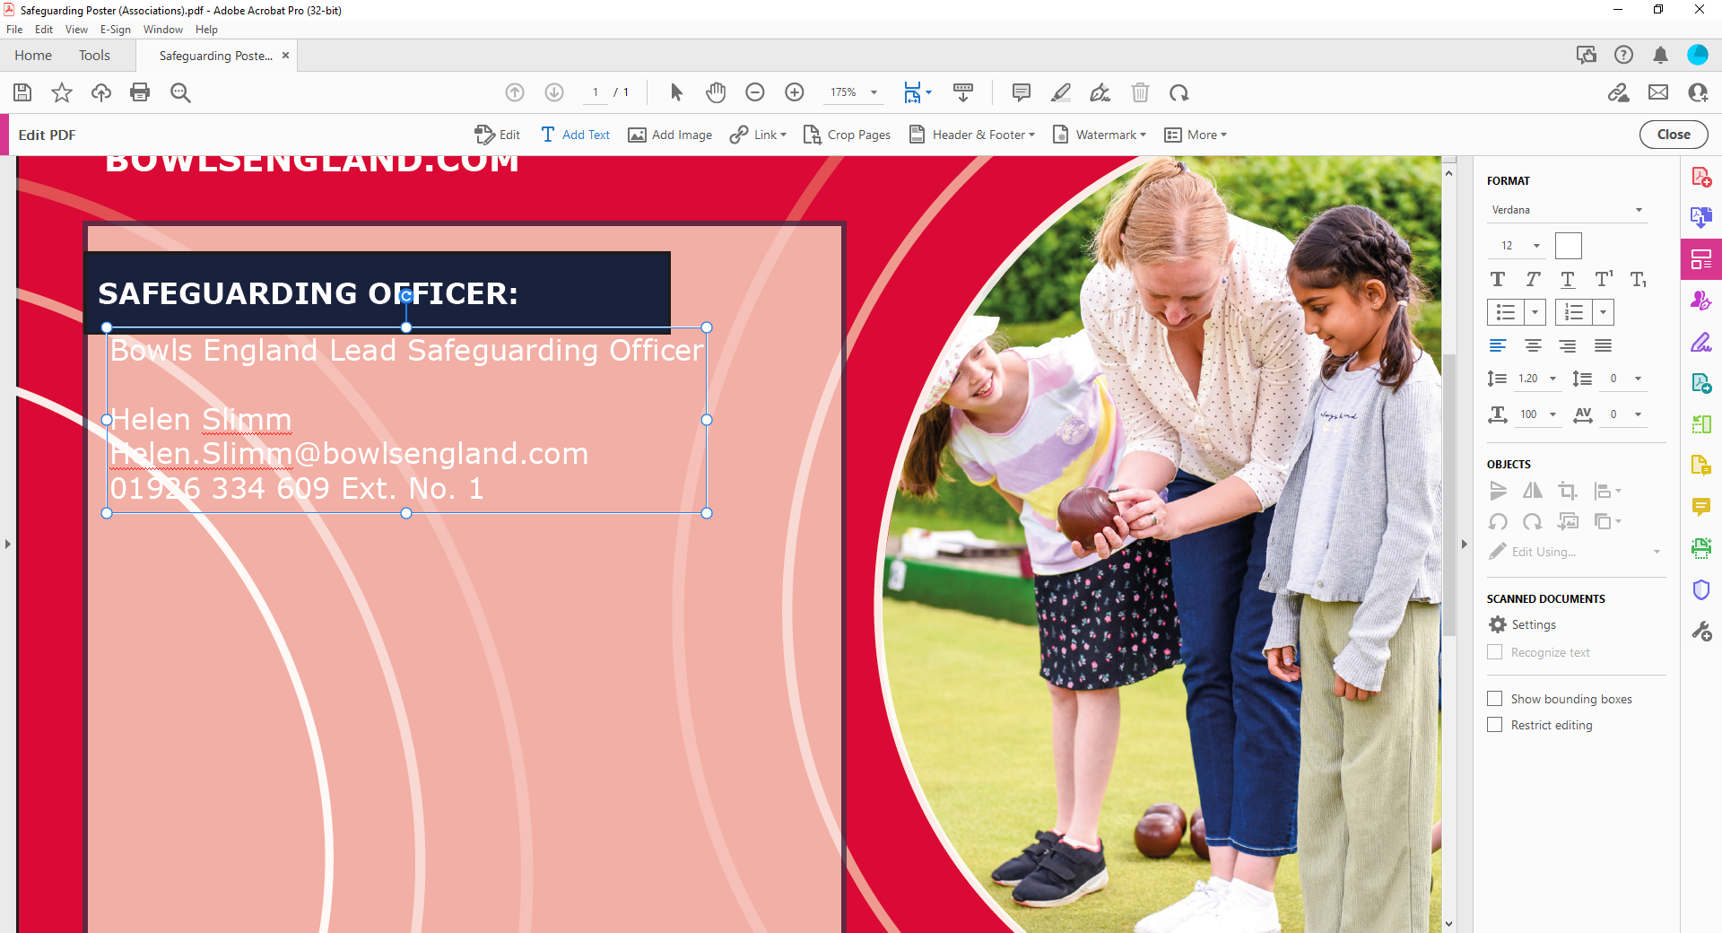

You have a ‘key’ on the left hand side – here you can change font colour, size etc:

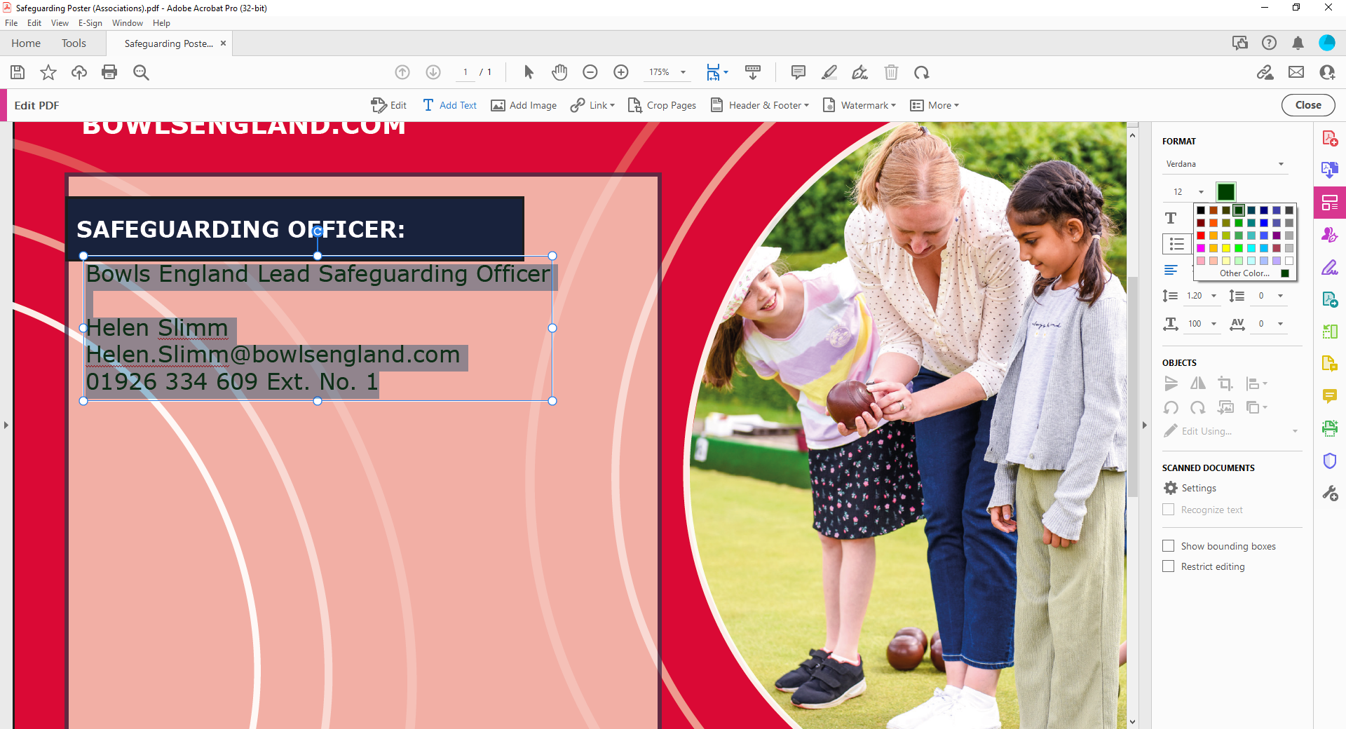

To change the size of the text box, click on the white dots and then drag to the size you wish:

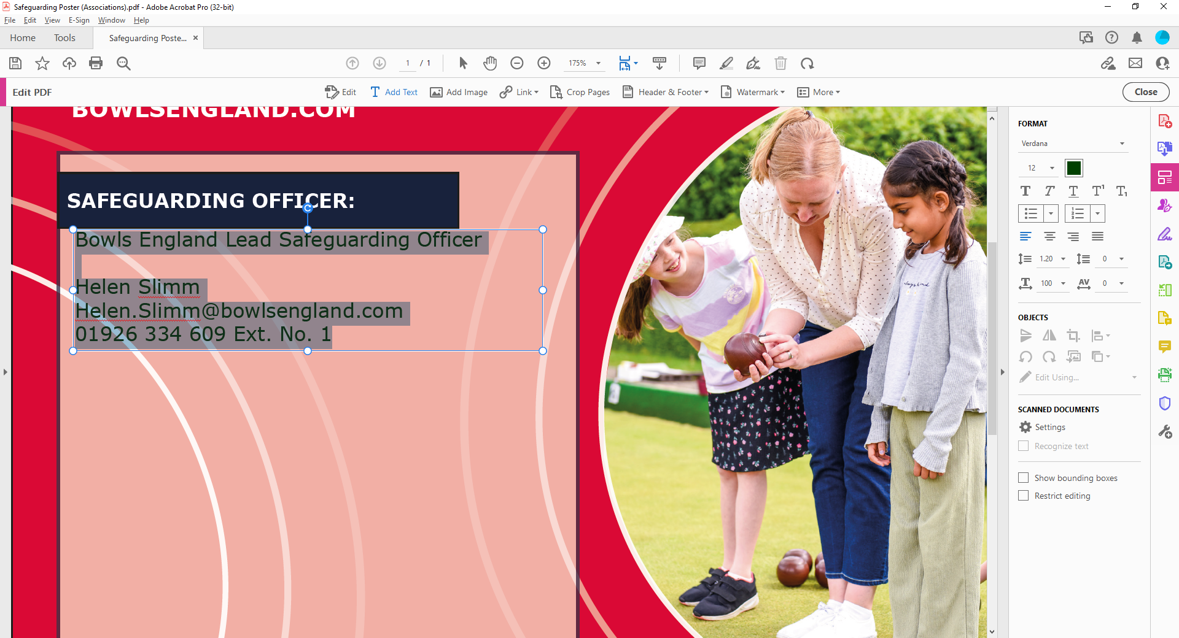

You can also add and image, go to the same icon bar at the top and click add image:

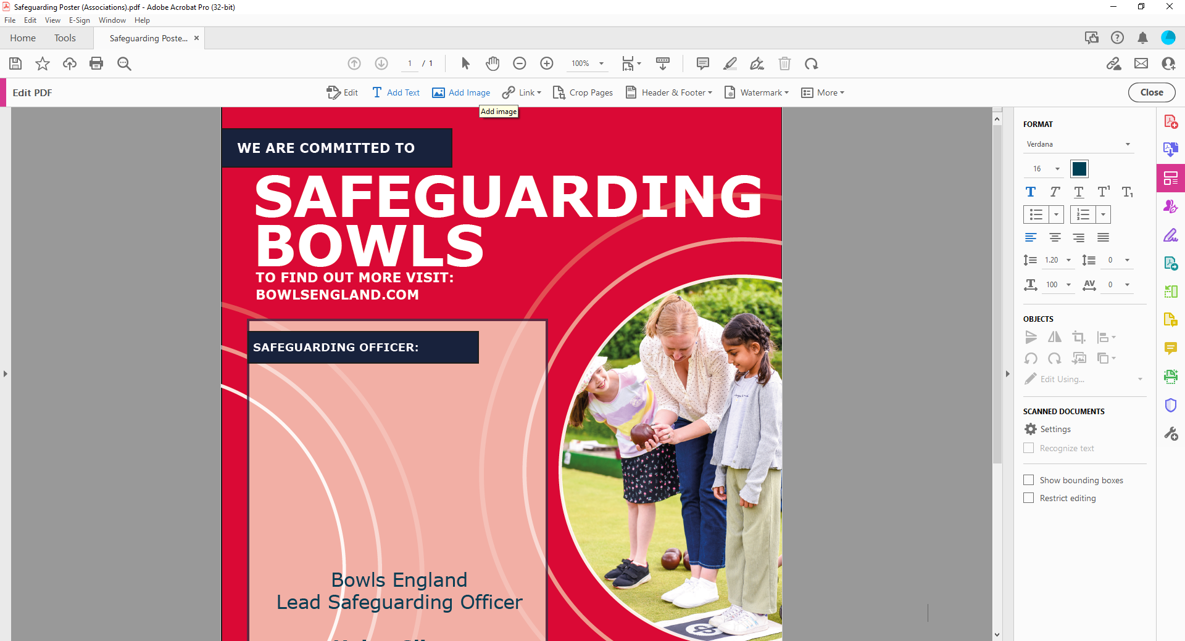

This will then allow you to add a picture of your Safeguarding Officer as well:

